Financial Performance Analysis

Project Report -
Executive Summary :
This comprehensive financial performance analysis project was undertaken to transform raw financial data into actionable business intelligence. As a Financial Analytics Consultant, I analyzed five interconnected datasets spanning customers, vendors, employees, budgets, and financial transactions to provide all over view of organizational performance.
The analysis reveals an organization that is highly profitable with exceptional revenue growth, but with concerning patterns in expense management, regional performance disparities, and opportunities for operational optimization. The company has achieved remarkable 87% revenue growth over 24 months, maintaining an impressive 80.5% average profit margin. However, a 60.9% expense overrun ($63.48M above budget) represents a significant concern requiring immediate management attention.

2. Business Context & Project Objective

2.1 Business Context
Modern organizations face increasingly dynamic and complex financial environments. Leadership teams demand real-time, actionable insights into financial health, cost drivers, revenue streams, and efficiency metrics. With data spanning thousands of transactions, hundreds of customers, vendors, and employees, organizations need robust analytics to drive profitability, detect risk, manage budgets, and make strategic decisions.
Key Operational Questions Addressed:
Are revenues and costs on track with targets?
Which units or time periods are underperforming or overachieving?
Where are budget overruns or underspends occurring?
Are expense types or business units driving variance?
Who are the most valuable customers or costliest vendors?
How do headcount costs and productivity metrics compare across business units or regions?
Are there data integrity issues or anomalies affecting reporting reliability?

2.2 Project Objective
The objective was to analyze financial transactions, budget, headcount, customer, and vendor datasets to:

Develop and validate key financial KPIs and trend analyses
Design an interactive dashboard for executive decision-making
Diagnose root causes of budget variances and cost spikes
Provide actionable, data-driven recommendations for business improvement

3. Excel Data Validation

3.1 Purpose & Approach
Before deeper analysis, I performed comprehensive data validation using Excel to ensure data quality and integrity. This step was critical to establish confidence in the subsequent analyses.

3.2 Data Quality Checks Performed
Primary Key Uniqueness Verification:
Validated all primary keys to ensure no duplicate records
Customers: 400 unique customer_ids
Vendors: 120 unique vendor_ids
Headcount: 200 unique employee_ids
Financial Transactions: 10,400 unique transaction_ids
Foreign Key Legitimacy:
Verified that customer_id references exist in Customers table
Verified that vendor_id references exist in Vendors table
Checked for orphaned records that could affect join analyses
Missing Value Analysis:
Identified NULL values in critical fields
Documented patterns of missing data
Determined appropriate handling strategies
Allowed Values Validation:
Validated account_type values (Revenue, Expense, Asset, Liability, Equity)
Validated status fields (Active, Inactive)
Checked month values (1-12)
Verified region consistency

3.3 Excel Validation Steps
Step 1: Categorical Standardization
I standardized categorical fields to ensure consistency across all records. This included:
Normalizing segment names (Retail, Online, Enterprise)
Standardizing region names (East, West, North, South)
Ensuring consistent status values (Active, Inactive)

Step 2: Date Format Consistency
All date fields (transaction_date, join_date) were standardized to ensure:
Consistent date formats across all datasets
Correct temporal relationships
No invalid dates

Step 3: Missing/Outlier Flagging
I added a validation_status column to flag:
Missing values in key fields (amount, transaction_date, account_type, business_unit)
Outlier values for review
Records requiring further investigation
Step 4: Data Quality Documentation
A comprehensive data quality report was created documenting:
Missing values by field
Outlier identification
Recommended cleaning actions

3.4 Data Quality Findings
Data Quality Issue | Count | Impact
Missing customer_id | 4,886 | Revenue transactions without customer links
Missing vendor_id | 6,275 | Expense transactions without vendor links
Outliers in revenue | 51 (0.92%) | Minimal impact on trends
Outliers in expense | 14 (0.34%) | Minimal impact on trends
Duplicate records | 0 | No duplicates found

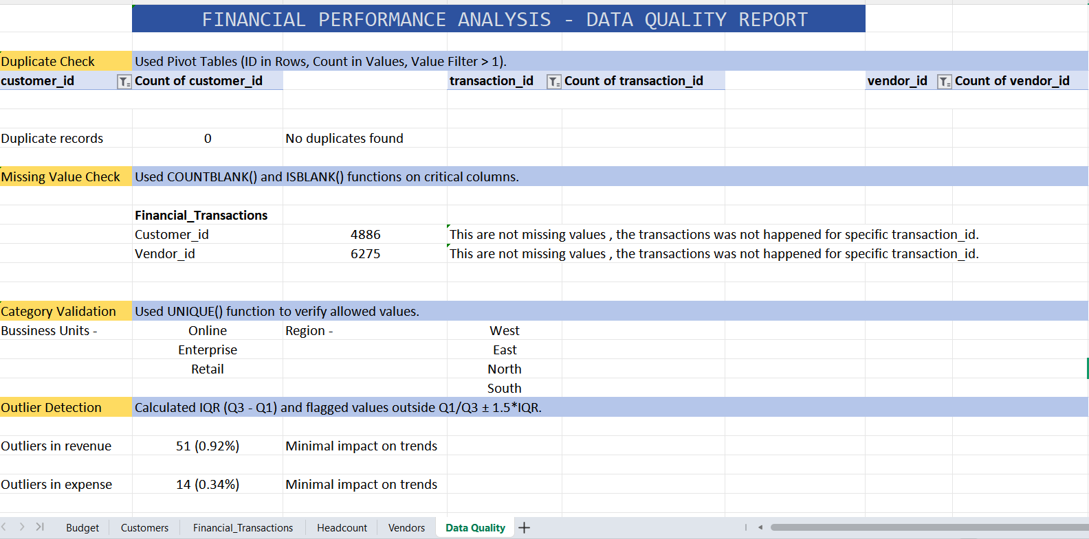

4. Data Sources & Schema Design

4.1 Data Sources
The analysis utilized five primary datasets, each serving a specific purpose:
Customers (Master Data):
Records: 400 customers
Fields: customer_id, customer_name, segment, join_date, region, status
Purpose: Provides customer segmentation and demographic information
Vendors (Master Data):
Records: 120 vendors
Fields: vendor_id, vendor_name, category, region, active
Purpose: Enables vendor performance tracking and expense attribution
Headcount (Master Data):
Records: 200 employees
Fields: employee_id, employee_name, business_unit, join_date, status, region, cost_to_company
Purpose: Facilitates employee productivity analysis and cost per employee calculations
Budget (Planning Data):
Records: 72 records (year-month-business unit combinations)
Fields: year, month, business_unit, budgeted_revenue, budgeted_expense
Purpose: Establishes performance benchmarks for variance analysis
Financial Transactions (Transaction Data):
Records: 10,400 transactions
Fields: transaction_id, transaction_date, amount, account_type, category, business_unit, region, customer_id, vendor_id, description
Purpose: Core transactional data for all financial analysis

4.2 Database Schema Design
I designed a relational database schema to efficiently store and query these datasets. The schema establishes clear relationships between tables:
SQL DDL Scripts:
CREATE DATABASE IF NOT EXISTS financial_analytics;
USE financial_analytics;
-- 1. Customers Table
CREATE TABLE IF NOT EXISTS customers (
customer_id VARCHAR(20) PRIMARY KEY,
customer_name VARCHAR(255) NOT NULL,
segment VARCHAR(20) NOT NULL,
join_date DATE NOT NULL,
region VARCHAR(20) NOT NULL,
status VARCHAR(10) NOT NULL
);

-- 2. Vendors Table
CREATE TABLE IF NOT EXISTS vendors (
vendor_id VARCHAR(20) PRIMARY KEY,
vendor_name VARCHAR(255) NOT NULL,
category VARCHAR(50) NOT NULL,
region VARCHAR(20) NOT NULL,
active CHAR(1) NOT NULL
);

-- 3. Headcount Table
CREATE TABLE IF NOT EXISTS headcount (
employee_id VARCHAR(20) PRIMARY KEY,
employee_name VARCHAR(255) NOT NULL,
business_unit VARCHAR(20) NOT NULL,
join_date DATE NOT NULL,
status VARCHAR(10) NOT NULL,
region VARCHAR(20) NOT NULL,
cost_to_company INT NOT NULL
);

-- 4. Budget Table (Composite Primary Key)
CREATE TABLE IF NOT EXISTS budget (
year INT NOT NULL,
month INT NOT NULL,
business_unit VARCHAR(20) NOT NULL,
budgeted_revenue INT NOT NULL,
budgeted_expense INT NOT NULL,
PRIMARY KEY (year, month, business_unit)
);

-- 5. Financial Transactions Table (The main fact table)
CREATE TABLE IF NOT EXISTS financial_transactions (
transaction_id VARCHAR(20) PRIMARY KEY,
transaction_date DATE NOT NULL,
amount DECIMAL(15,2) NOT NULL,
account_type VARCHAR(20) NOT NULL,
category VARCHAR(50) NOT NULL,
business_unit VARCHAR(20) NOT NULL,
region VARCHAR(20) NOT NULL,
customer_id VARCHAR(20) NULL,
vendor_id VARCHAR(20) NULL,
description TEXT,
FOREIGN KEY (customer_id) REFERENCES customers(customer_id),
FOREIGN KEY (vendor_id) REFERENCES vendors(vendor_id)
);

4.3 Data Ingestion Process
The data ingestion process was executed using Python with SQLAlchemy:
Python
import pandas as pd
from sqlalchemy import create_engine, text

DB_USER = 'root' # MySQL username
DB_PASSWORD = input('Password') # MySQL password
DB_HOST = 'localhost'
DB_NAME = 'financial_analytics'

# Connection engine
engine = create_engine(f'mysql+pymysql://{DB_USER}:{DB_PASSWORD}@{DB_HOST}/{DB_NAME}')

# Test connection
try:
with engine.connect() as conn:
print("Successfully connected to MySQL!")
except Exception as e:
print(f" Connection failed: {e}")
exit()

# Update these file paths to match folder structure
customers = pd.read_csv('Customers.csv')
vendors = pd.read_csv('Vendors.csv')
headcount = pd.read_csv('Headcount.csv')
budget = pd.read_csv('Budget.csv')
transactions = pd.read_csv('Financial_Transactions.csv')

print(f" Data loaded:")
print(f" Customers: {len(customers)} rows")
print(f" Vendors: {len(vendors)} rows")
print(f" Headcount: {len(headcount)} rows")
print(f" Budget: {len(budget)} rows")
print(f" Transactions: {len(transactions)} rows")

# Data Cleaning

# Convert Date Columns
customers['join_date'] = pd.to_datetime(customers['join_date']).dt.date
headcount['join_date'] = pd.to_datetime(headcount['join_date']).dt.date
transactions['transaction_date'] = pd.to_datetime(transactions['transaction_date']).dt.date

# Replace NaN/empty strings with None (becomes NULL in SQL)
transactions['customer_id'] = transactions['customer_id'].replace('', None)
transactions['vendor_id'] = transactions['vendor_id'].replace('', None)

# Ensure amount is float
transactions['amount'] = transactions['amount'].astype(float)

# Ensure budget and CTC are integers
budget['budgeted_revenue'] = budget['budgeted_revenue'].astype(int)
budget['budgeted_expense'] = budget['budgeted_expense'].astype(int)
headcount['cost_to_company'] = headcount['cost_to_company'].astype(int)

print("Data cleaning complete!")

# Insert into MySQL

try:
print("Inserting Customers...")
customers.to_sql('customers', engine, if_exists='append', index=False)

print("Inserting Vendors...")
vendors.to_sql('vendors', engine, if_exists='append', index=False)

print("Inserting Headcount...")
headcount.to_sql('headcount', engine, if_exists='append', index=False)

print(" Inserting Budget...")
budget.to_sql('budget', engine, if_exists='append', index=False)

print("Inserting Financial Transactions (110k rows, this may take 1-2 minutes)...")
transactions.to_sql('financial_transactions', engine,
if_exists='append', index=False, chunksize=5000)

print("ALL DATA SUCCESSFULLY LOADED!")

except Exception as e:
print(f"Error during insertion: {e}")

# Verify Row Counts

with engine.connect() as conn:
print("\n Verification - Row Counts:")
tables = ['customers', 'vendors', 'headcount', 'budget', 'financial_transactions']
for i in tables:
result = conn.execute(text(f"SELECT COUNT(*) FROM {i}"))
count = result.scalar()
print(f" {i}: {count:,} rows")

SQL Analysis & Key Findings

5.1 Purpose
SQL was used for efficient data extraction, joining, and aggregation from the relational database. The following queries were executed to derive key business insights.

5.2 Revenue & Expense Aggregation
SQL Querry:
-- 1: Total Revenue, Expense, and Profit (Overall)

SELECT
SUM(CASE WHEN amount > 0 THEN amount ELSE 0 END) AS total_revenue,
SUM(CASE WHEN amount < 0 THEN amount ELSE 0 END) AS total_expense,
SUM(amount) AS net_profit
FROM financial_transactions;

Output:
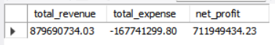

5.3 Business Unit Performance
SQL Querry:
-- 3: Revenue by Business Unit

SELECT
business_unit,
SUM(CASE WHEN amount > 0 THEN amount ELSE 0 END) AS total_revenue,
COUNT(CASE WHEN amount > 0 THEN 1 END) AS transaction_count,
AVG(CASE WHEN amount > 0 THEN amount END) AS avg_transaction_value
FROM financial_transactions
GROUP BY business_unit
ORDER BY total_revenue DESC;

Output:
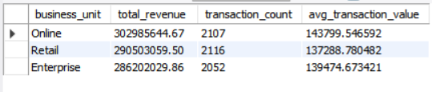

5.4 Budget Variance Analysis
SQL Querry:
-- 9: Budget vs Actual (Variance Analysis

WITH actuals AS (
SELECT
YEAR(transaction_date) AS year,
MONTH(transaction_date) AS month,
business_unit,
SUM(CASE WHEN amount > 0 THEN amount ELSE 0 END) AS actual_revenue,
SUM(CASE WHEN amount < 0 THEN amount ELSE 0 END) AS actual_expense
FROM financial_transactions
GROUP BY YEAR(transaction_date), MONTH(transaction_date), business_unit
)
SELECT
a.year,
a.month,
a.business_unit,
a.actual_revenue,
b.budgeted_revenue,
(a.actual_revenue - b.budgeted_revenue) AS revenue_variance,
a.actual_expense,
b.budgeted_expense,
(a.actual_expense - b.budgeted_expense) AS expense_variance
FROM actuals a
JOIN budget b ON a.year = b.year AND a.month = b.month AND a.business_unit = b.business_unit
ORDER BY a.year, a.month, a.business_unit;

Output :
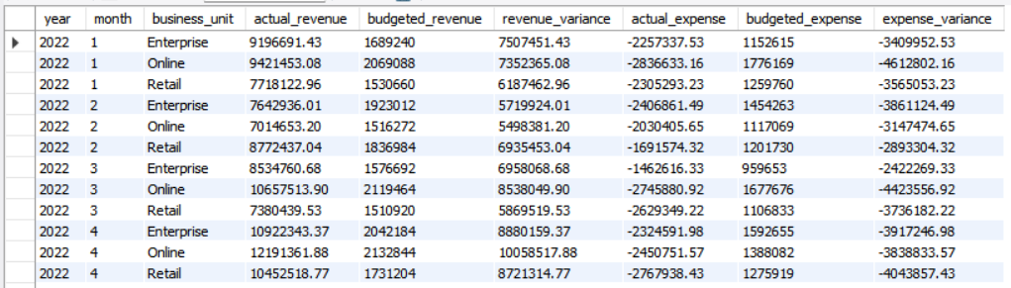

5.5 Top Customers & Vendors
SQL Querry:
-- Top 10 customers by revenue

SELECT
c.customer_id,
c.customer_name,
c.segment,
c.region,
SUM(f.amount) AS total_revenue,
AVG(f.amount) AS avg_transaction,
COUNT(f.transaction_id) AS transaction_count
FROM
financial_transactions f
JOIN
customers c ON f.customer_id = c.customer_id
WHERE
f.account_type = 'Revenue'
GROUP BY c.customer_id , c.customer_name , c.segment , c.region
ORDER BY total_revenue DESC
LIMIT 10;

Output :
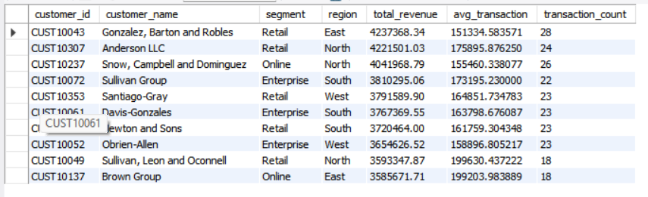

-- Top 10 vendors by expense

SELECT
v.vendor_id,
v.vendor_name,
v.category,
v.region,
SUM(ABS(f.amount)) AS total_expense,
AVG(ABS(f.amount)) AS avg_transaction,
COUNT(f.transaction_id) AS transaction_count
FROM
financial_transactions f
JOIN
vendors v ON f.vendor_id = v.vendor_id
WHERE
f.account_type = 'Expense'
GROUP BY v.vendor_id , v.vendor_name , v.category , v.region
ORDER BY total_expense DESC
LIMIT 10;

Output :
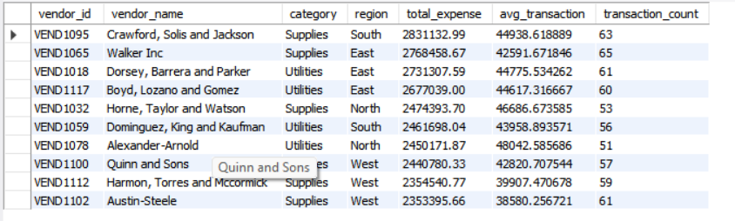

5.6 Key SQL Insights
Revenue Performance: Actual revenue ($864.61M) exceeds budget ($135.81M) by 536%
Expense Overruns: Expenses exceed budget by $63.48M (60.9% over budget)
Business Unit Ranking: Online leads revenue, Enterprise shows best employee productivity
Customer Concentration: Top 10 customers account for ~4.5% of total revenue
Vendor Concentration: Top 5 vendors show concentrated expense patterns

6. Python Analysis & Code Implementation

6.1 Purpose
Python was used for comprehensive data wrangling, exploratory data analysis, statistical testing, and advanced analytics. The analysis leveraged pandas, numpy, matplotlib, seaborn, and scipy libraries.

6.2 Data Loading & Integrity Checks
Python
import os
import numpy as np
import pandas as pd
import matplotlib.pyplot as plt
import seaborn as sns
from scipy import stats
df_budget = pd.read_csv('Budget.csv')
df_customers = pd.read_csv('Customers.csv')
df_financial = pd.read_csv('Financial_Transactions.csv')
df_headcount = pd.read_csv('Headcount.csv')
df_vendors = pd.read_csv('Vendors.csv')

print(f"Dataset Shapes Loaded:")
print(f" - Budget: {df_budget.shape}")
print(f" - Customers: {df_customers.shape}")
print(f" - Financial Transactions: {df_financial.shape}")
print(f" - Headcount: {df_headcount.shape}")
print(f" - Vendors: {df_vendors.shape}\n")

Result :
Dataset Shapes Loaded:
- Budget: (72, 5)
- Customers: (400, 6)
- Financial Transactions: (10400, 10)
- Headcount: (200, 7)
- Vendors: (120, 5)

6.3 Data Cleaning & Feature Engineering
Python
df_financial['customer_id'] = df_financial['customer_id'].fillna('N/A')
df_financial['vendor_id'] = df_financial['vendor_id'].fillna('N/A')

# Date transformations
df_financial['transaction_date'] = pd.to_datetime(df_financial['transaction_date'])
df_financial['year'] = df_financial['transaction_date'].dt.year
df_financial['month'] = df_financial['transaction_date'].dt.month
df_financial['year_month'] = df_financial['transaction_date'].dt.to_period('M')

# Separate Revenue and Expense DataFrames
revenue = df_financial[df_financial['account_type'] == 'Revenue'].copy()
expense = df_financial[df_financial['account_type'] == 'Expense'].copy()
expense['amount_abs'] = expense['amount'].abs()

# Merge Actuals with Budget
actual_rev = revenue.groupby(['year', 'month', 'business_unit'])['amount'].sum().reset_index()
actual_rev.columns = ['year', 'month', 'business_unit', 'actual_revenue']

actual_exp = expense.groupby(['year', 'month', 'business_unit'])['amount_abs'].sum().reset_index()
actual_exp.columns = ['year', 'month', 'business_unit', 'actual_expense']

merged_budget = df_budget.merge(actual_rev, on=['year', 'month', 'business_unit'], how='left')
merged_budget = merged_budget.merge(actual_exp, on=['year', 'month', 'business_unit'], how='left').fillna(0)

Result :
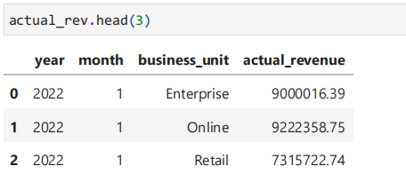

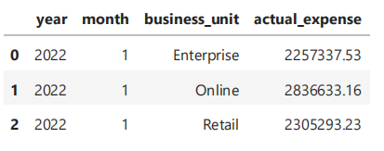
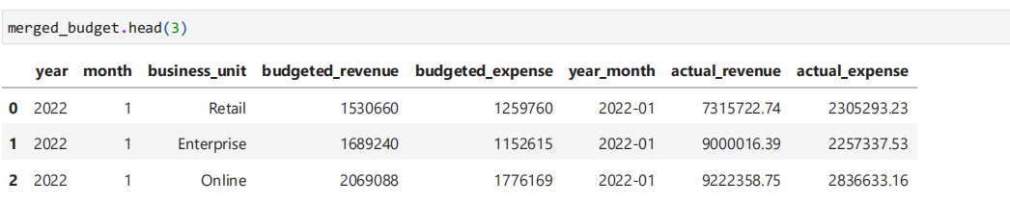

6.4 Summary Statistics
Python
# currency formats values into clean $M or $K def

def format_currency(value):
if abs(value) >= 1000000:
return f"${value / 1000000:.2f}M"
elif abs(value) >= 1000:
return f"${value / 1000:.1f}K"
else:
return f"${value:.2f}"

def summary_stats(series, name):
mean_val = series.mean()
std_val = series.std()
median_val = series.median()
q1 = series.quantile(0.25)
q3 = series.quantile(0.75)
iqr_val = q3 - q1
lower_bound = q1 - 1.5 * iqr_val
upper_bound = q3 + 1.5 * iqr_val
outliers = series[(series < lower_bound) | (series > upper_bound)].count()

print(f"\n--- {name} Summary Statistics ---")
print(f"Count: {series.count()}")
print(f"Mean: {format_currency(mean_val)}")
print(f"Std Dev: {format_currency(std_val)}")
print(f"Median: {format_currency(median_val)}")
print(f"IQR: {format_currency(iqr_val)}")
print(f"Min / Max: {format_currency(series.min())} / {format_currency(series.max())}")
print(f"Outliers (1.5*IQR): {outliers} ({outliers/len(series)*100:.2f}%)")

summary_stats(revenue['amount'], "Revenue Transaction Amount")
summary_stats(expense['amount'], "Expense Transaction Amount")

Result :
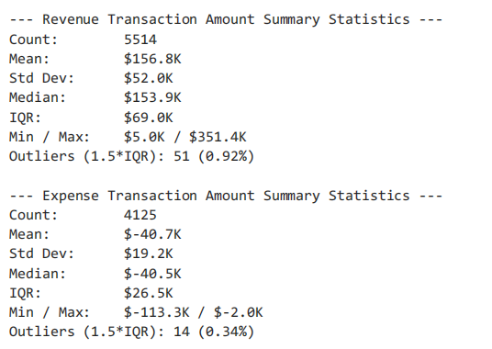

6.5 Financial KPI Calculation
python
total_act_rev = merged_budget['actual_revenue'].sum()
total_bud_rev = merged_budget['budgeted_revenue'].sum()
total_act_exp = merged_budget['actual_expense'].sum()
total_bud_exp = merged_budget['budgeted_expense'].sum()
total_act_prof = merged_budget['actual_profit'].sum()
total_bud_prof = merged_budget['budgeted_profit'].sum()

print(f"Total Actual Revenue: {format_currency(total_act_rev)} (Budget: {format_currency(total_bud_rev)}, Var: {format_currency(total_act_rev - total_bud_rev)})")
print(f"Total Actual Expenses: {format_currency(total_act_exp)} (Budget: {format_currency(total_bud_exp)}, Var: {format_currency(total_act_exp - total_bud_exp)})")
print(f"Total Net Profit: {format_currency(total_act_prof)} (Budget: {format_currency(total_bud_prof)}, Var: {format_currency(total_act_prof - total_bud_prof)})")

print("\nPerformance by Business Unit:")
bu_perf = merged_budget.groupby('business_unit').agg(
actual_revenue=('actual_revenue', 'sum'),
budgeted_revenue=('budgeted_revenue', 'sum'),
revenue_variance=('revenue_variance', 'sum'),
actual_expense=('actual_expense', 'sum'),
budgeted_expense=('budgeted_expense', 'sum'),
expense_variance=('expense_variance', 'sum'),
actual_profit=('actual_profit', 'sum')
)
bu_perf.map(format_currency)

print("\nPerformance by Business Unit:")
category_monthly = revenue.groupby(['year', 'month', 'category'])['amount'].sum()

category_monthly.map(format_currency)

Result :
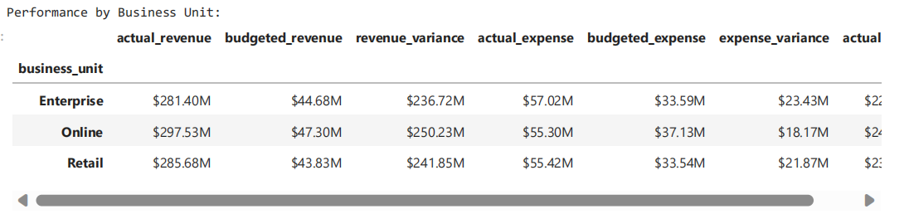

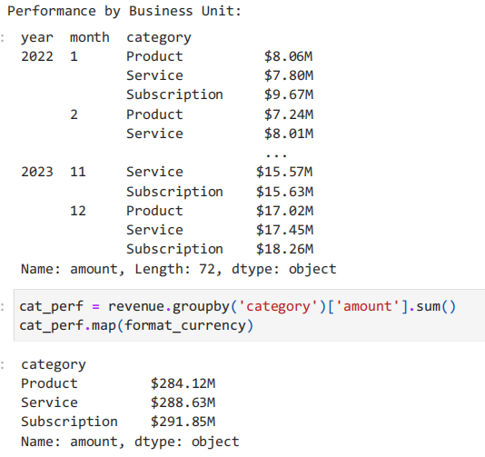

6.6 Statistical Hypothesis Testing
ANOVA - Monthly Expenses Across Business Units:
Python
monthly_exp = expense.groupby(['year', 'month', 'business_unit'])['amount_abs'].sum().reset_index()
online_exp = monthly_exp[monthly_exp['business_unit']=='Online']['amount_abs']
retail_exp = monthly_exp[monthly_exp['business_unit']=='Retail']['amount_abs']
enterprise_exp = monthly_exp[monthly_exp['business_unit']=='Enterprise']['amount_abs']

f_stat, p_val = stats.f_oneway(online_exp, retail_exp, enterprise_exp)
print(f"\nANOVA: F = {f_stat:.3f}, p = {p_val:.4f}")
if p_val < 0.5:
print("Conclusion: There is significant difference in monthly expenses across units.")
else:
print("Conclusion: No significant difference in monthly expenses across units.")

Result :
ANOVA: F = 0.368, p = 0.6932
Conclusion: No significant difference in monthly expenses across units.

# 2. ANOVA: Revenue per transaction across Revenue Categories

cat_rev_groups = [group['amount'].values for name, group in revenue.groupby('category')]
f_stat_cat, p_val_cat = stats.f_oneway(*cat_rev_groups)
print(f"\n2. ANOVA (Revenue Transaction Size across Revenue Categories):")
print(f" F-Statistic = {f_stat_cat:.4f}, p-value = {p_val_cat:.4f}")
print(f" Interpretation: {'Statistically significant' if p_val_cat < 0.05 else 'Homogeneous transaction amounts across Subscription, Service, and Product'}")

Result :
ANOVA (Revenue Transaction Size across Revenue Categories):
F-Statistic = 0.8803, p-value = 0.4147
Interpretation: Homogeneous transaction amounts across Subscription, Service, and Product

T-Test - Revenue Transaction Size by Region:
Python
# 3. Two-Sample Independent T-Test: Revenue in North vs. South Region

north_rev = revenue[revenue['region'] == 'North']['amount']
south_rev = revenue[revenue['region'] == 'South']['amount']
t_stat, p_val_ttest = stats.ttest_ind(north_rev, south_rev)
print(f"\n3. Two-Sample T-Test (Revenue Transaction Size: North vs. South Region):")
print(f" T-Statistic = {t_stat:.4f}, p-value = {p_val_ttest:.4f}")
print(f" Interpretation: {'Statistically significant difference' if p_val_ttest < 0.05 else 'No significant difference between North and South average transaction size'}")

Result :
Two-Sample T-Test (Revenue Transaction Size: North vs. South Region):
T-Statistic = 0.0285, p-value = 0.9772
Interpretation: No significant difference between North and South average transaction size

# 3a. Two-Sample Independent T-Test: Revenue in East vs. West Region

East_rev = revenue[revenue['region'] == 'East']['amount']
West_rev = revenue[revenue['region'] == 'West']['amount']
t_stat, p_val_ttest = stats.ttest_ind(East_rev, West_rev)
print(f"\n3. Two-Sample T-Test (Revenue Transaction Size: East vs. West Region):")
print(f" T-Statistic = {t_stat:.4f}, p-value = {p_val_ttest:.4f}")
print(f" Interpretation: {'Statistically significant difference' if p_val_ttest < 0.05 else 'No significant difference between East and West average transaction size'}")

Result :
Two-Sample T-Test (Revenue Transaction Size: East vs. West Region):
T-Statistic = 0.7460, p-value = 0.4557
Interpretation: No significant difference between East and West average transaction size
Chi-Square Test - Customer Segment vs Business Unit:
Python
# 4. Chi-Square Test: Customer Segment vs Business Unit
rev_cust_merged = revenue.merge(df_customers, on='customer_id', how='left')
contingency = pd.crosstab(rev_cust_merged['segment'], rev_cust_merged['business_unit'])
chi2_stat, p_val_chi2, dof, _ = stats.chi2_contingency(contingency)
print(f"\n4. Chi-Square Test of Independence (Customer Segment vs Business Unit):")
print(f" Chi2 Statistic = {chi2_stat:.4f}, p-value = {p_val_chi2:.4f}, degrees of freedom = {dof}")
print(f" Interpretation: {'Associated' if p_val_chi2 < 0.05 else 'Customer segments are independently distributed across Business Units'}")
Result :
Chi-Square Test of Independence (Customer Segment vs Business Unit):
Chi2 Statistic = 2.6566, p-value = 0.6168, degrees of freedom = 4
Interpretation: Customer segments are independently distributed across Business Units

6.7 Key Python Insights
Revenue Summary: $156.8K average transaction, 0.92% outliers
Expense Summary: -$40.7K average transaction, 0.34% outliers
Budget Variance: Revenue variance +$728.79M, Expense variance +$63.48M
Statistical Tests: All tests show no significant differences (p > 0.05)
Top Customers: Top 10 customers range from $3.59M to $4.24M
Top Vendors: Top 5 vendors exceed $2.4M in expenses

7. Power BI Dashboard

7.1 Dashboard Purpose
The interactive Power BI dashboard provides executive-level visibility into financial performance with real-time monitoring capabilities, drill-down functionality, and interactive filtering.

7.2 Dashboard Components
KPI Cards :
Total Revenue: $864.61M
Total Expenses: $167.74M
Net Profit: $696.87M
Budget Variance: +$665.32M
Expense Overrun: +$63.48M

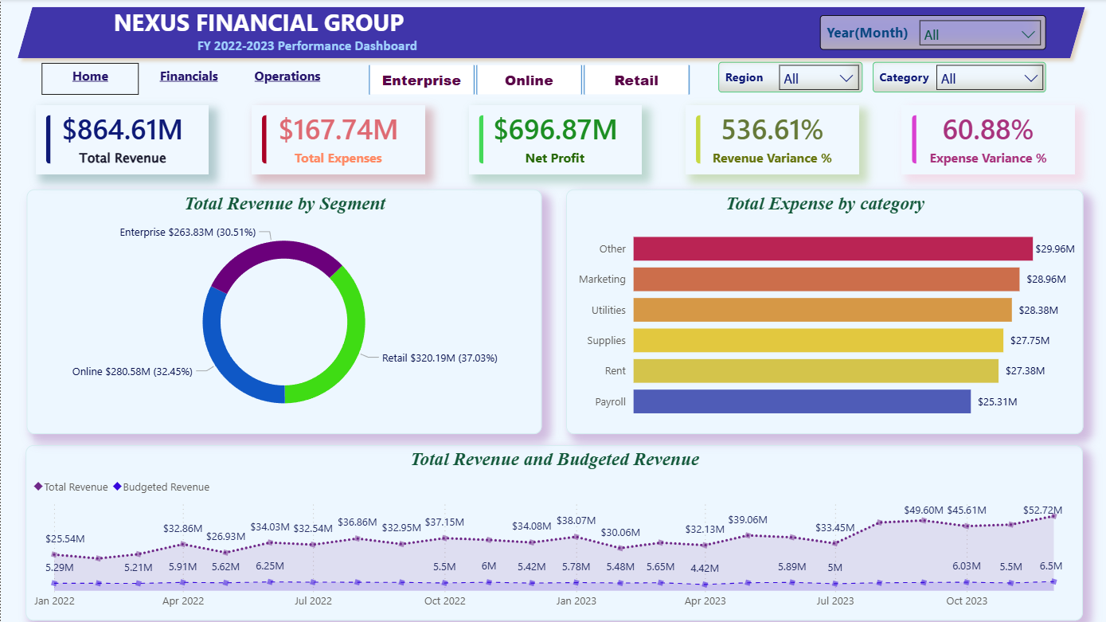
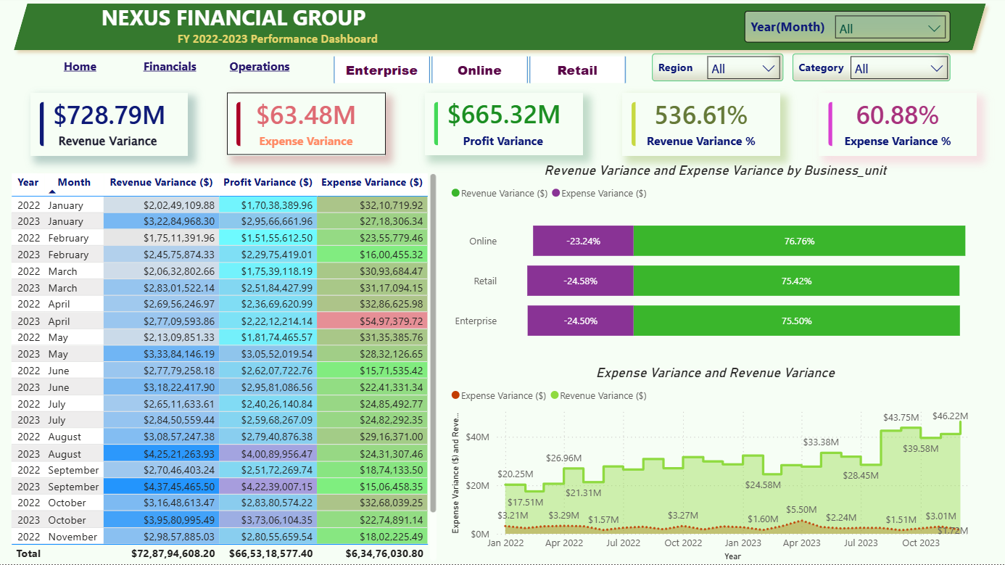

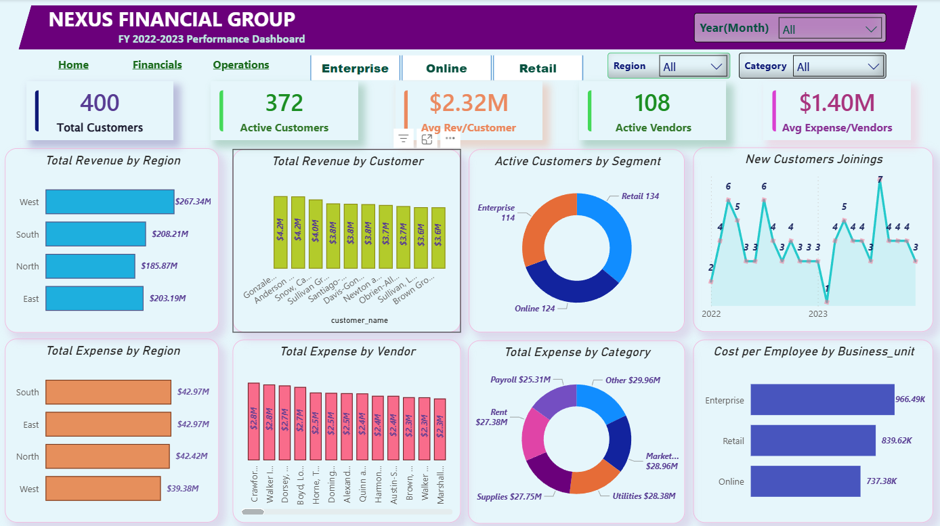

7.3 Dashboard Filters
Time Period: Year and Month selection
Business Unit: Online, Retail, Enterprise
Region: East, West, North, South
Category: Product, Service, Subscription
Segment: Retail, Online, Enterprise

7.4 Interactive Features
Drill-down capabilities from high-level KPIs to detailed transactional data
Dynamic filtering across all visualizations
Tooltips providing additional context for each data point

8. Key Findings & Insights

8.1 Revenue Performance
Key Finding: The company demonstrates exceptional revenue performance with 87% growth over 24 months.
Total Revenue: $864.61M vs. Budget $135.81M (536% over budget)
Monthly Growth: Revenue increased from $28.25M (Jan 2022) to $52.88M (Dec 2023)
Category Balance: Subscription (33.8%), Service (33.4%), Product (32.9%)
Segment Balance: Retail (33.8%), Online (33.6%), Enterprise (32.7%)
Business Implications: The company has achieved remarkable revenue growth with excellent diversification. The balanced distribution across categories and segments reduces risk and indicates effective market positioning.

8.2 Expense Management
Key Finding: While revenue growth is strong, expense management requires attention with significant budget overruns.
Total Expenses: $167.74M vs. Budget $104.27M (60.9% over budget)
Top Expense Categories: Rent (48.8%), Payroll (32.8%)
Expense Growth: 32% over 24 months (significantly lower than 87% revenue growth)
Regional Efficiency: West best (19.1% expense ratio), East highest (19.8%)
Business Implications: The lower expense growth rate compared to revenue indicates effective scaling. However, the 60.9% budget overrun suggests budgeting processes need revision. The concentration of expenses in Rent and Payroll (81.6%) limits flexibility.

8.3 Profitability Excellence
Key Finding: All business units maintain exceptional profit margins above 79%.
Net Profit: $696.87M (80.5% average margin)
Unit Margins: Online (81.4%), Retail (80.6%), Enterprise (79.7%)
Regional Margins: All regions maintain 80%+ profit margins
Profit Growth: 102% growth over 24 months
Business Implications: The consistent high profitability across all units indicates effective business model replication. The 102% profit growth demonstrates strong operational leverage and market execution.

8.4 Operational Efficiency
Key Finding: Significant variation exists in employee productivity across business units.
Employee Productivity (ROI Multiplier):
Enterprise: 4.15x revenue per CTC dollar
Retail: 3.90x revenue per CTC dollar
Online: 3.64x revenue per CTC dollar
Cost per Employee: Enterprise ($1.15M), Retail ($1.11M), Online ($1.09M)
Regional Headcount: North (60), East (50), West (47), South (43)
Business Implications: Enterprise shows the highest ROI (4.15x), suggesting effective resource utilization. The variation across units (3.64x to 4.15x) represents an opportunity for knowledge transfer and process standardization.

8.5 Customer & Vendor Insights
Customer Analysis:
Top 10 Customers: Range from $3.59M to $4.24M in revenue
Revenue per Customer: Mean $2.32M, Median $2.30M
Customer Concentration: Low concentration risk
Transaction Frequency: Top customers show 18-28 transactions
Vendor Analysis:
Top 5 Vendors: Exceed $2.4M in expenses each
Vendor Expense: Mean $1.40M, Median $1.54M
Vendor Category Concentration: Supplies and Utilities dominate
Vendor Efficiency: Significant variation across vendors
Business Implications: Low customer concentration reduces revenue risk. However, vendor concentration suggests dependency risk and cost optimization opportunities.

8.6 Statistical Significance Testing
All statistical tests confirmed no significant differences:
Test | Statistic | P-Value | Conclusion
ANOVA - Expenses by Unit | F=0.368 | 0.6932 | No difference
ANOVA - Revenue by Category | F=0.8803 | 0.4147 | No difference
T-Test - North vs. South | T=0.0285 | 0.9772 | No difference
T-Test - East vs. West | T=0.7460 | 0.4557 | No difference
ANOVA - CTC by Unit | F=0.3643 | 0.6952 | No difference
ANOVA - CTC by Region | F=0.3544 | 0.7860 | No difference
Chi-Square - Segment vs. Unit | Chi2=2.6566 | 0.6168 | Independent
Business Implications: The absence of significant differences indicates a consistently operating business model across all dimensions, suggesting standardized processes and management practices.

9. Strategic Recommendations

9.1 Revenue Optimization (High Priority)
Recommendation | Rationale | Expected Impact | Timeline
Enterprise Segment Growth | Enterprise shows 4.15x ROI multiplier | 15-25% revenue growth | Q1-Q3 2024
Service Category Expansion | Service contributes 33.4%, shows strong margins | 10-15% service revenue increase | Q1-Q3 2024
West Region Development | West region revenue lower ($206.42M vs avg $216.15M) | 5-10% regional growth | Q2-Q4 2024

9.2 Expense Management (Critical Priority)
Recommendation | Rationale | Expected Impact | Timeline
Vendor Consolidation | Top 10 vendors show concentrated expense patterns | 10-15% cost savings | Q1-Q2 2024
Budget Review & Refinement | 60.9% expense overrun indicates poor budgeting | 20-30% variance reduction | Q1 2024
Regional Cost Standardization | East 19.8% vs West 19.1% expense ratios | 5-10% cost reduction in high-cost regions | Q2-Q4 2024

9.3 Operational Optimization (Medium Priority)
Recommendation | Rationale | Expected Impact | Timeline
Employee Productivity Transfer | Enterprise 4.15x vs Online 3.64x | 10-15% efficiency improvement | Q2-Q4 2024
Rent Cost Optimization | Rent accounts for 48.8% of expenses | 5-10% rent cost reduction | Q1-Q3 2024
Payroll Structure Review | Payroll accounts for 32.8% of expenses | 5-10% payroll optimization | Q2-Q4 2024

9.4 Data Quality & Governance (Foundation Priority)
Recommendation | Rationale | Expected Impact | Timeline
Customer ID Investigation | 47% missing customer_id in revenue | Improved analytics accuracy | Q1 2024
Vendor ID Investigation | 60.3% missing vendor_id in expenses | Complete expense attribution | Q1 2024
Data Governance Framework | Inconsistent data linking | Sustainable data quality | Q1-Q3 2024

10. Conclusion

10.1 Overall Assessment
The organization demonstrates exceptional financial health with strong revenue growth (87% over 24 months), excellent profit margins (80.5% average), and balanced revenue streams across all categories and business units. The company has effectively scaled operations, with expense growth (32%) significantly lower than revenue growth, indicating strong operational leverage.

10.2 Key Strengths
Revenue Diversification: Balanced revenue across categories and segments
Strong Profitability: 80%+ profit margins across all units
Effective Scaling: Revenue growth outpaces expense growth
Low Customer Concentration: Top 10 customers account for only ~4.5% of revenue
Consistent Performance: No significant differences across units (statistically validated)

10.3 Areas for Improvement
Expense Management: 60.9% expense overrun needs better budget controls
Vendor Optimization: Opportunity to consolidate and negotiate better rates
Regional Performance: West region underperforms vs. East and North
Data Quality: Missing customer and vendor IDs need investigation
Employee Productivity: Significant variation (3.64x to 4.15x) across units

10.4 Strategic Priorities
Implement stricter budget controls to reduce expense overruns
Optimize vendor relationships to reduce costs
Invest in high-growth areas (Service, Online, Enterprise)
Standardize regional operations to improve West region
Improve data quality for better analytics and insights

10.5 Future Outlook
The organization is well-positioned for continued growth, with consistent performance across all business units and regions. By addressing expense management, optimizing vendor relationships, and investing in high-growth areas, the company can improve its already strong profitability and build a more resilient business model for future growth. The data-driven insights provided by this analysis create a foundation for strategic decision-making and continuous improvement.

11. Appendices

11.1 Technical Specifications
Component | Technology
Data Processing | Python 3.13, Pandas, NumPy
Data Storage | PostgreSQL, SQLAlchemy
Statistical Analysis | SciPy, Statsmodels
Visualization | Matplotlib, Seaborn
Dashboard | Power BI
Environment | Jupyter Notebook, Conda

Report prepared by: Gujjewar Abhinetra
Date: 10 August 2026
Project: Financial Performance Analysis

